Nama Kelompok : 1. Imam Syafii (15.01.53.0150)
2. Togar Hatopan (15.01.53.0153)

Tugas klasifikasi menggunakan klasifikasi R

- Ambil data dari
Archive.ics.uci.edu/ml/datasets.html

- Disini kelompok kami mengambil Balance-Scale Dataset
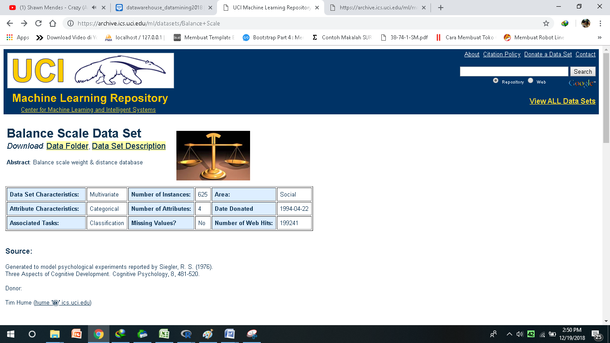

- Lalu kita import balance-scale.data ke excel dan menambahkan field diatasnya sebagai berikut, setelah itu disimpan dalam format .xlxs
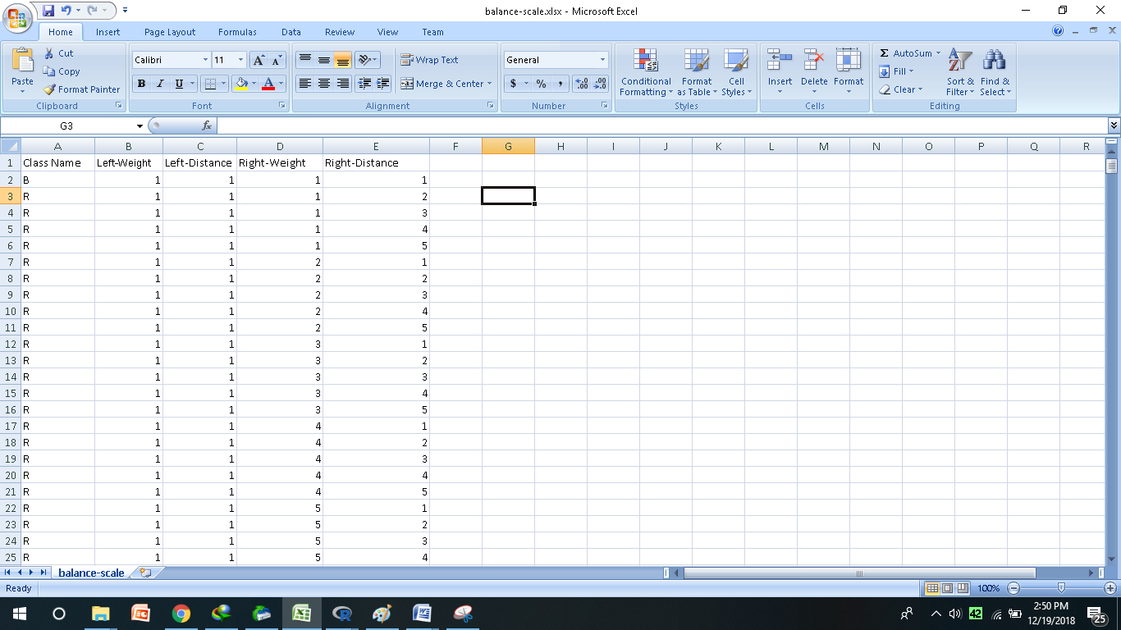

- Kita masuk ke R Comander dan memilih Package – Package Load - Rcmdr
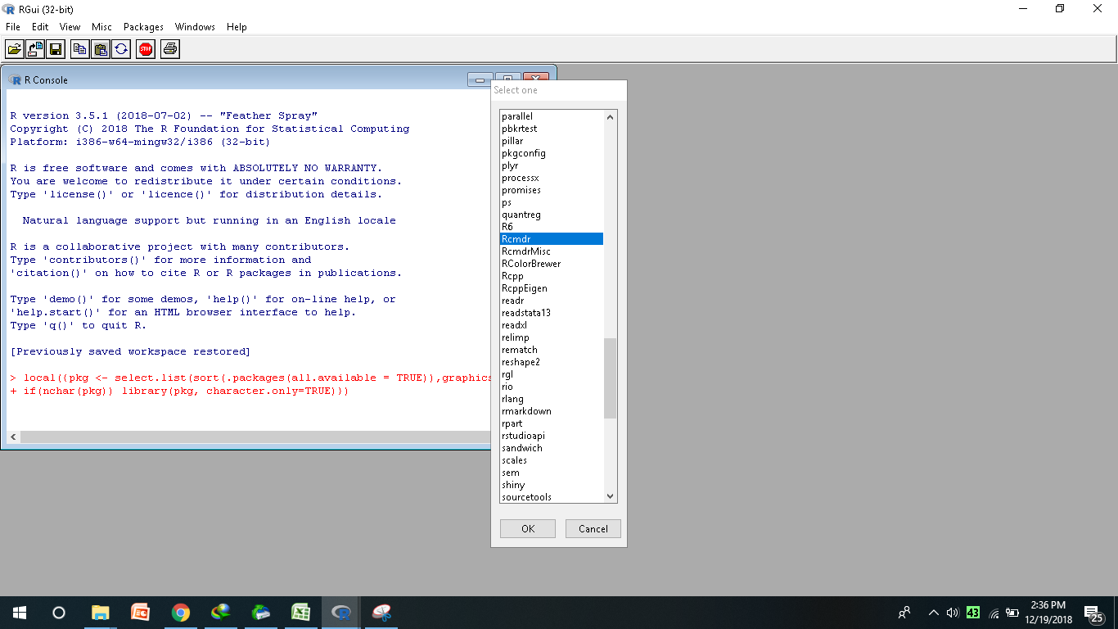

- Untuk memasukan data excel kedalam R ialah dengan Klik Data – Import Data – from excel file.
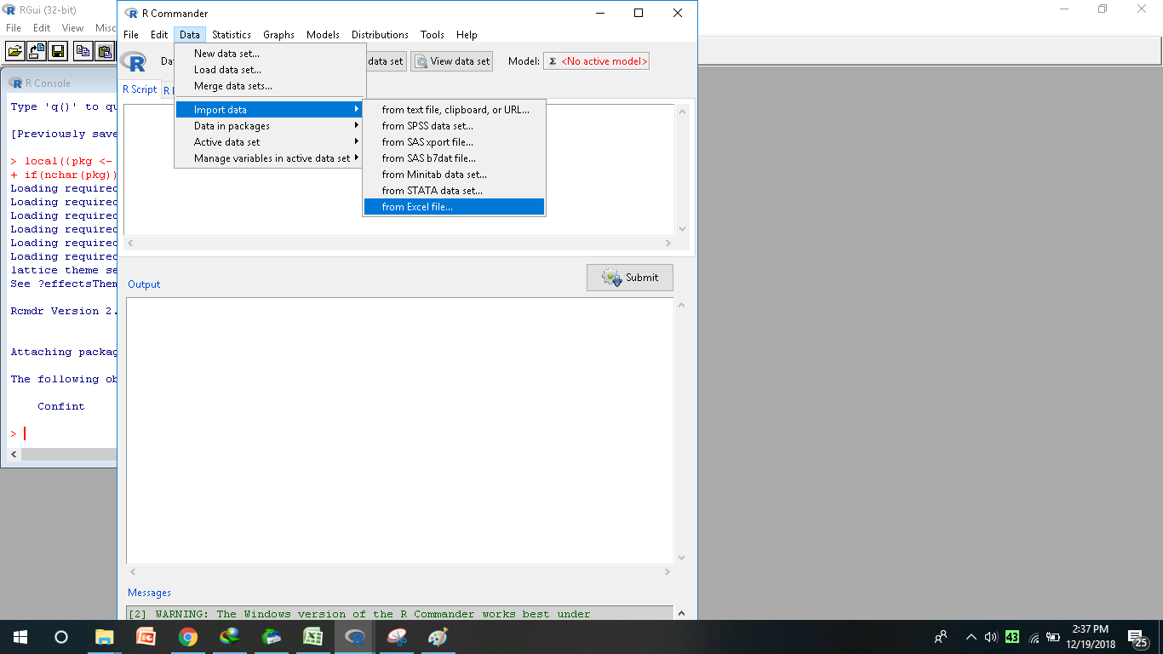

- Setelah data berhasil dimasukan kemudian klik view dataset untuk menampilkan dalam bentuk dataset
(Class Nama ) - (Left-Weight) - (Left-Distance) - (Right-Weight) - (Right-Distance)
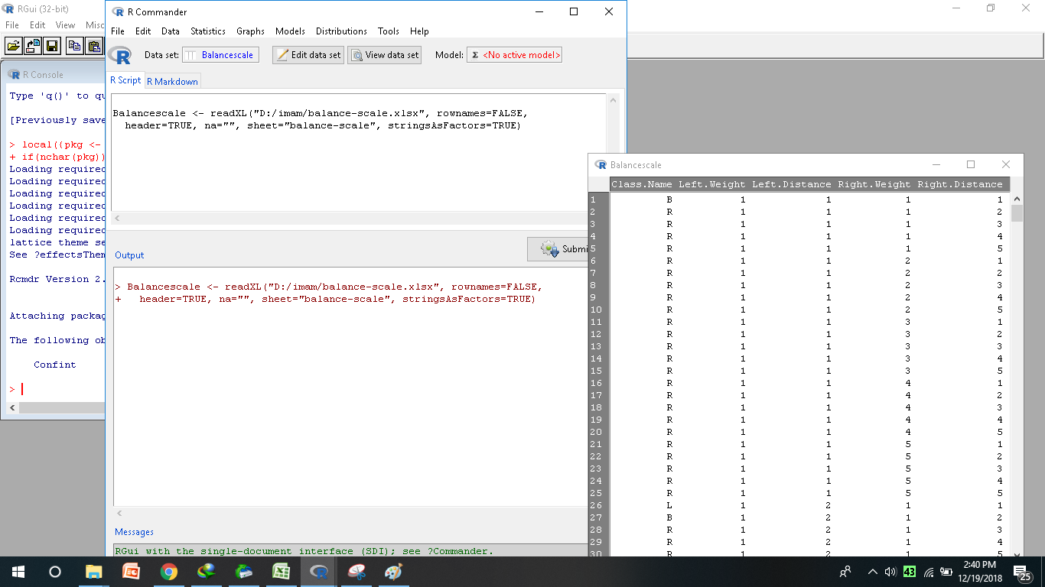

- Selanjutnya data kita mengaktifkan data dengan menekan Statistics – Summaries – Active dataset.
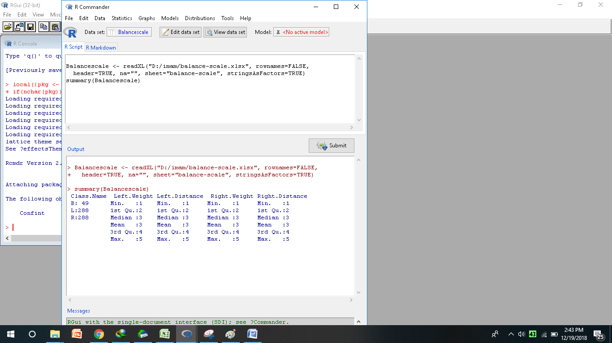

- Selanjutnya menekan Statistics – Summaries – Numerical summaries.
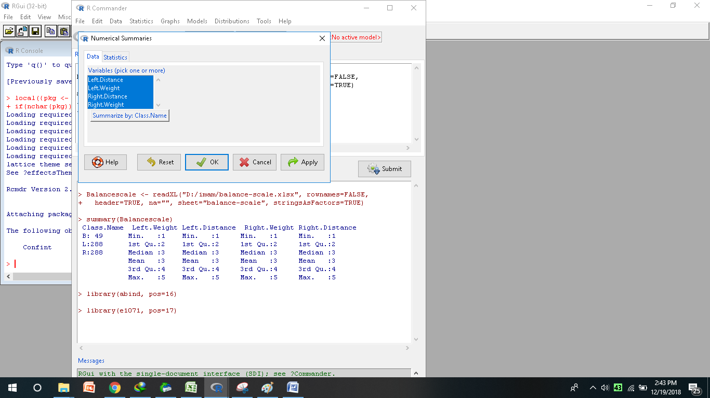

- Untuk menampilkan hasil dari klasifikasinya dengan menekan Graph – Scatterplot Matrix
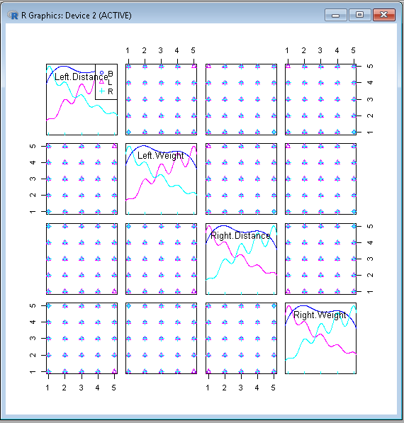

Listing Program Script:
Balancescale <- readXL("D:/imam/balance-scale.xlsx", rownames=FALSE,
header=TRUE, na="", sheet="balance-scale", stringsAsFactors=TRUE)
summary(Balancescale)
library(abind, pos=16)
library(e1071, pos=17)
numSummary(Balancescale[,c("Left.Distance", "Left.Weight", "Right.Distance",
"Right.Weight"), drop=FALSE], groups=Balancescale$Class.Name,
statistics=c("mean", "sd", "IQR", "quantiles"), quantiles=c(0,.25,.5,.75,1))
scatterplotMatrix(~Left.Distance+Left.Weight+Right.Distance+Right.Weight |
Class.Name,
regLine=FALSE, smooth=FALSE,
diagonal=list(method="density"), by.groups=TRUE, data=Balancescale)

Listing Program Output
> Balancescale <- readXL("D:/imam/balance-scale.xlsx", rownames=FALSE,
+ header=TRUE, na="", sheet="balance-scale", stringsAsFactors=TRUE)

> summary(Balancescale)
Class.Name Left.Weight Left.Distance Right.Weight Right.Distance
B: 49 Min. :1 Min. :1 Min. :1 Min. :1
L:288 1st Qu.:2 1st Qu.:2 1st Qu.:2 1st Qu.:2
R:288 Median :3 Median :3 Median :3 Median :3
Mean :3 Mean :3 Mean :3 Mean :3
3rd Qu.:4 3rd Qu.:4 3rd Qu.:4 3rd Qu.:4
Max. :5 Max. :5 Max. :5 Max. :5

> library(abind, pos=16)

> library(e1071, pos=17)

> numSummary(Balancescale[,c("Left.Distance", "Left.Weight", "Right.Distance",
+ "Right.Weight"), drop=FALSE], groups=Balancescale$Class.Name,
+ statistics=c("mean", "sd", "IQR", "quantiles"), quantiles=c(0,.25,.5,.75,1))

Variable: Left.Distance
mean sd IQR 0% 25% 50% 75% 100% n
B 2.938776 1.420214 2 1 2 3 4 5 49
L 3.611111 1.227508 2 1 3 4 5 5 288
R 2.399306 1.331840 2 1 1 2 3 5 288

Variable: Left.Weight
mean sd IQR 0% 25% 50% 75% 100% n
B 2.938776 1.420214 2 1 2 3 4 5 49
L 3.611111 1.227508 2 1 3 4 5 5 288
R 2.399306 1.331840 2 1 1 2 3 5 288

Variable: Right.Distance
mean sd IQR 0% 25% 50% 75% 100% n
B 2.938776 1.420214 2 1 2 3 4 5 49
L 2.399306 1.331840 2 1 1 2 3 5 288
R 3.611111 1.227508 2 1 3 4 5 5 288

Variable: Right.Weight
mean sd IQR 0% 25% 50% 75% 100% n
B 2.938776 1.420214 2 1 2 3 4 5 49
L 2.399306 1.331840 2 1 1 2 3 5 288
R 3.611111 1.227508 2 1 3 4 5 5 288

> scatterplotMatrix(~Left.Distance+Left.Weight+Right.Distance+Right.Weight |
+ Class.Name,
+ regLine=FALSE, smooth=FALSE,
+ diagonal=list(method="density"), by.groups=TRUE, data=Balancescale)

